SAMUVEL M

# INFORMATION TECHNOLOGY

CAREER OBJECTIVE

To gain knowledge and experience varied skills and to work for the company's betterment to attain their targets and goals and to enrich my skills

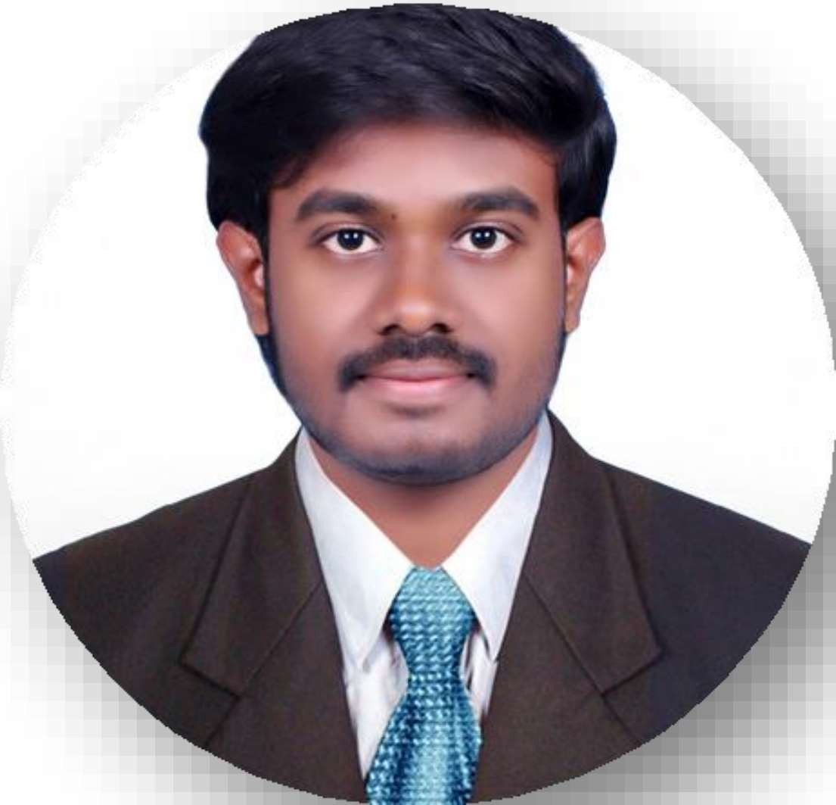

# EDUCATION

B.Sc. INFORMATION TECHNOLOGY (2021-2024)

KPR College of Arts Science and Research, Coimbatore. Overall percentage – 81.5%

**CERTIFICATIONS**

* Frontend Development HTML - Great Learning
* Frontend Development CSS - Great Learning
* My SQL Basics -Great Learning

# ROLES AND RESPONSIBILITIES

* Public Relation (PRO) Officer - KPRCAS Rotaract Club (2022- 2023)
* Sergeant at Arms - KPRCAS Rotaract Club (2023 - 2024)
* Fine Arts Club President (Music Club) — KPRCAS Served as council member - RacKPRCAS (2022- 2024)

# INTERNSHIP

**Cloud Computing** —Accent techno soft Nehru street | Coimbatore | 19th Jan 2023 - 27th Jan 2023

* Acquired hands-on experience with Amazon Web Services (AWS) platform. Gained knowledge in cloud architecture, deployment models, and various AWS services.

## VALUE ADDED COURSE

Problem Solving using Oops - Tedora Techno Lab, The Bodacious Bosses - 45 Hours - Dec 31, 2022 to Jan 7, 2023

## PARTICI PATION

Power BI workshop – Skill Nation

Relationship Management Training - Rotaract on July 2023

CONTACT

Ph:8925609393

[samuelzeran@gmail.com](mailto:samuelzeran@gmail.com) Linkedln

# AREA OF INTEREST

* Cloud Computing
* Web development
* Digital Marketing

## TECHNICAL SKILLS

* HTML, CSS
* Python
* My SQL
* MS Office

## SOFT SKILLS

* Emotional Intelligence
* Leadership
* Communication
* Teamwork
* Public speaking

## DECLARATION

I Hereby declare that the details above are correct and true to the best of my knowledge.